**MINI PROJECT -2**

**(2020-2021)**

**Student Management System Based Web Application**

**FINAL REPORT**



**Institute of Engineering & Technology**

**Submitted by**

**Mukul Joshi(181500399)**

**Aditya Pandey (181500043)**

**Devansh Pandey(181500212)**

***Supervised By: -***

**Ms. Priya Agarwal**

**(Technical Trainer)**

**Department of Computer Engineering & Applications**

**Acknowledgement :**

* We would like to give special thanks of gratitude to our mentor Ms. Priya Agarwal and our project coordinator for supporting us at every moment.
* We all team members learn many things during this project.
* The completion of the project is possible only with the support of team members:

* Aditya Pandey. * Mukul Joshi. * Devansh Pandey.

**INDEX:**

* **Acknowledgement**
* **Index page**
* **Project details**
* **Project description**
* **Working code along with file name**
* **Working Screenshots**
* **Data Flow Diagrams**
* **Level-00**
* **Level-01**
* **Level-02**

**\*\* Summary/conclusion**

**\*\* References**

**PROJECT DETAILS:**

* It is a Student Management System based website which is used to provide various facilities under one common roof.
* The technologies used in these projects are:
* XAMPP /WAMPP
* MySQL
* HTML, CSS, JAVASCRIPT
* PHP

**PROJECT DESCRIPTION:**

**FEATURES:**

* Admin Login.
  + Product Entry.
  + View users’ details.
  + View Order.
* User Login/Registration.
* Add to Cart.
* Pay using Card.
* View order.

**Project Implementation Details:**

∙ Firstly, we will make a log-in page for the user, the user can sign-up on our website through his mobile number & then log-in after completing the sign-up process.

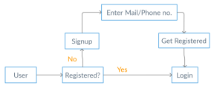

∙ After log-in into his account, user can get the option of adding course details into stock including details like course name, course date, creation date.

∙ He can also view the data of that he has in his store.

**Project Implementation Technology:**

* The project is loaded in sublime text
* We used sublime text for design and coding of project.
* Created and maintained all database into SQL Server 2008, in that we

create tables, write query for store data or record of projects.

**Technologies used:**

* Browser: Google Chrome/ Firefox.
* Front-End : HTML, CSS, JavaScript.
* Programming language: PHP / JAVA /
* Frameworks: Node.js /
* Database: MySQL / Oracle / MongoDB.
* Git Package
* Sublime/ Notepad++ As IDE
* XAMPP/WAMPP SERVER

**WORKING CODE WITH ALONG FILE NAME:**

**WORKING SCREEN-SHOTS :**

* USER LOGIN.
* WELCOME page.
* DAILY SALES pages.
* EXPIRED ITEMS pages.
* DETAILS pages.
* PRINT-DETAILS pages.
* ENTRY page.
* NEW-STOCKS page.
* MESSAGE box.
* CONFORMATION box.
* ADD to CART page.
* Some other pages.

**DATA FLOW DIAGRAMS:**

* In this section of report we will see about different types of data flow diagrams related to our project:
  + 0 level DFD.
  + 1 level DFD.
  + 2 level DFD.
  + 3 level DFD.

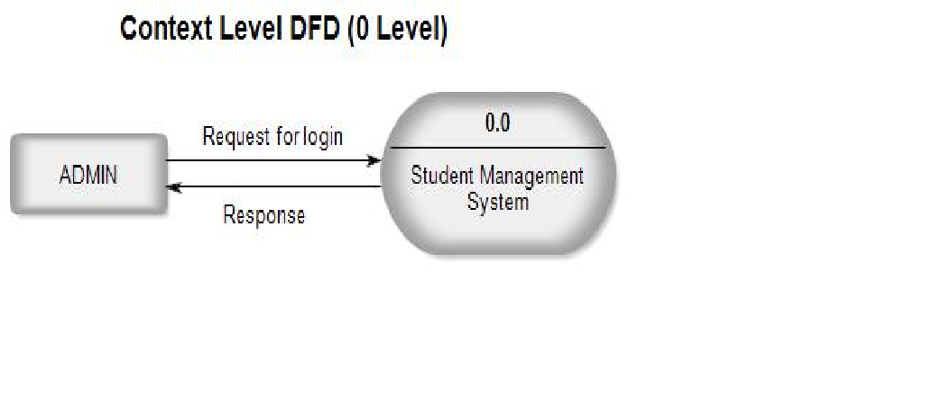

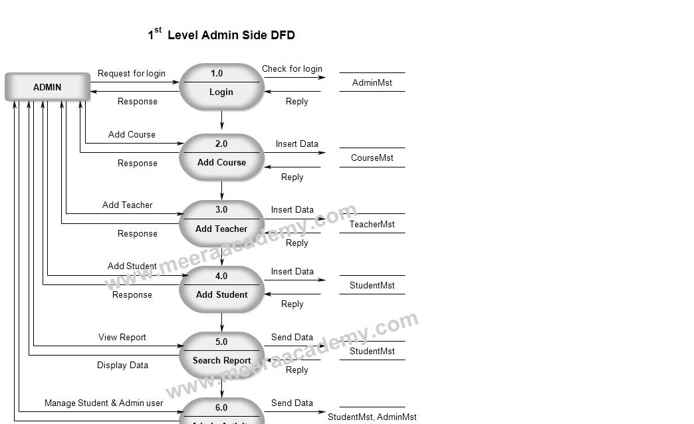

**First Level DFD**

**Second Level DFD**

**SUMMARY / CONCLUSION:**

* It has user friendly interface which reduces the efforts of the user as well as for the administrator.
* It's basic aim is to provide self-health and solve the problems or issues by your own.
* It is a management system.
* It provides from consultation to purchasing medicines which reduces all efforts of the user to use different-different website or application to solve different-different problems related to health.
* It reduces the travelling and doctor's cost as well.
* Cheaper.
* Can be used Anywhere, Anytime.
* Reduces the patient tension.
* Helpful every-where and every-time

**REFERENCES:**

**https://beta-labs.in**

**https://hackr.io/tutorials/learn-bootstrap https://www.learn-html.org/**

**https://bootstrapbay.com/blog/learn-bootstrap/ https://www.w3schools.com/html**

**https://www.udemy.com/html-css-bootstrap/**